**4 Jan 2019** **The Weekly Bulletin of Rotary Club of Kathmandu Mid-Town** **bc-15.1/019**

|  |
| --- |
| C:\Users\Public\Documents\RIP T1819_EN.png |

District: 3292 Web:www.rotarymidtown.org.np Club Id: 26776

**JANUARY IS VOCATIONAL SERVICE MONTH**

**Vocational Service focuses on**:

Adherence to and promotion of the highest ethical standards in all occupations, including fair treatment of employers, employees, associates, competitors, and the public.

The recognition of the worthiness of all useful occupations, not just those that are pursued by Rotarians.

The contribution of your vocational talents to solving the problems of society and meeting the needs of the community.

**28 Dec 018 Friday**

**Club Meeting # 1470**

Guest speaker Dr Milan Maharjan talked about ear care services in Nepal. She spoke about the lack of ear surgery capability and lack of awareness in general. She has done Ear Camps in over 28 schools and her team have screened approx. over 5,000 patients and has conducted about 100 surgeries.

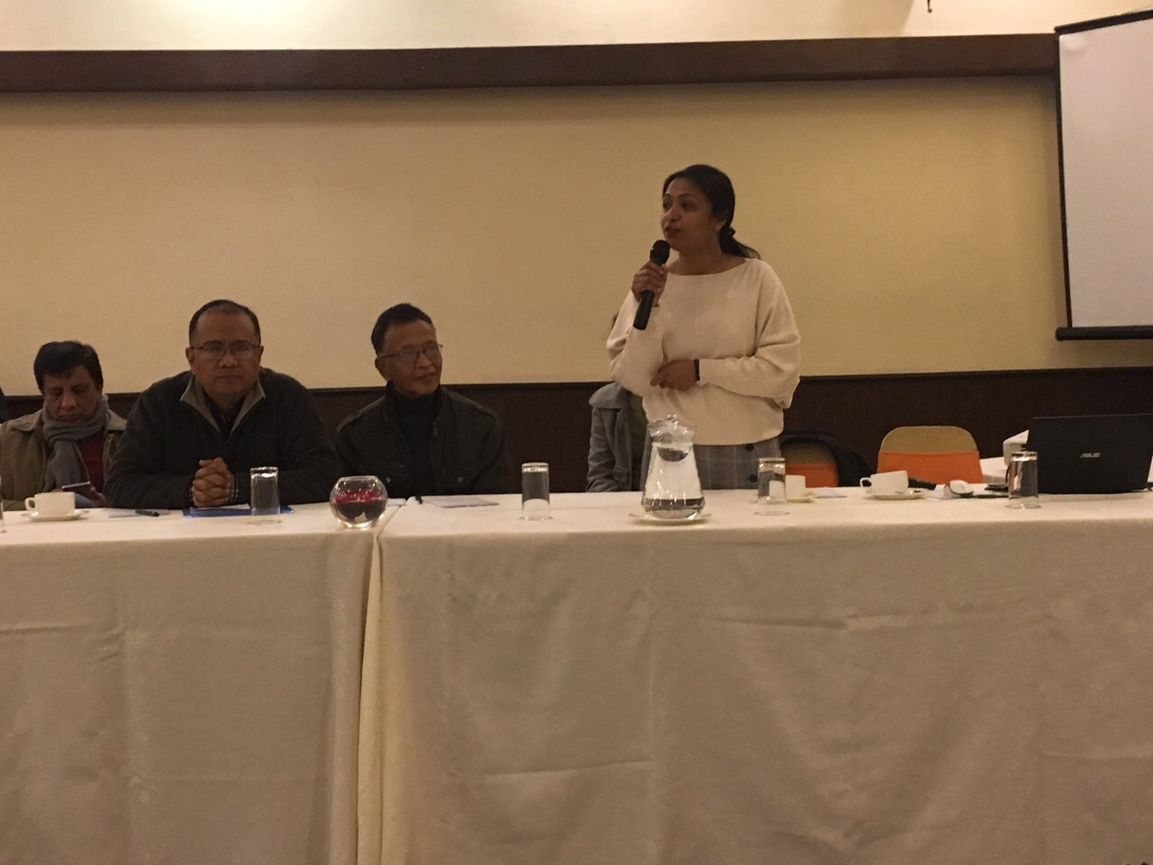 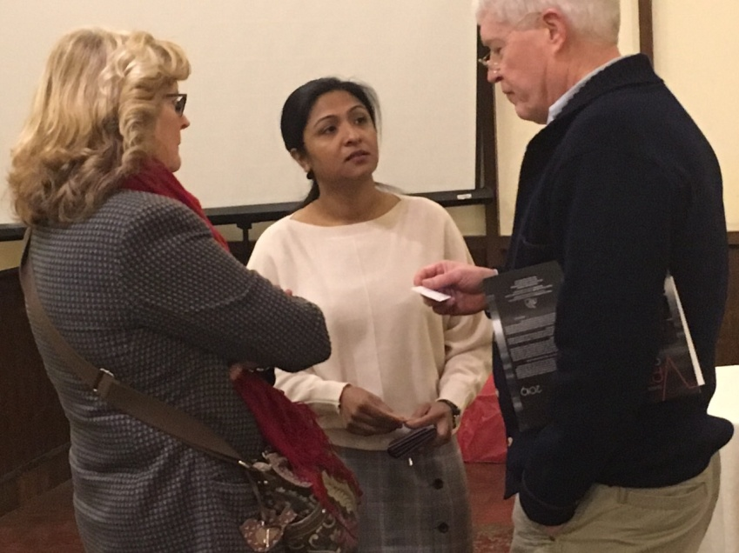

*Photo courtesy: Rtn Shyam R Thapalia*

**Weekly Meeting # 1471 on Friday, 4 Jan 2019**

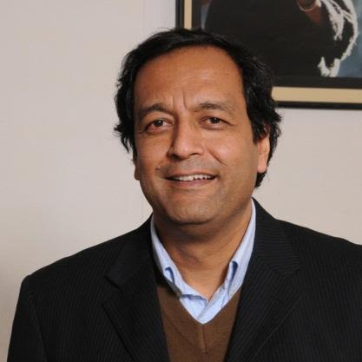

Our guest speaker is our own Mid-Towner Dr Budha Basnet. He will be talking on

"Typhoid, Typhus and TB - studies in South Asia"

He works at Patan Hospital as a consultant in the internal medicine department and is

Professor of Medicine and Physiology at the Patan Academy of Health Sciences. He is the

Director for Oxford University Clinical Research Unit\Nepal , a research collaboration of

Oxford University with Patan Hospital. He gives his time as Medical Director for Nepal

International Clinic (a travel medicine clinic) and also for the Himalayan Rescue Association

(on high altitude medical problems). He has research interests in the areas of infectious

diseases & high altitude symptoms/treatment and encourages young people to do research.

As a Fellow of the American College of Physicians and Fellow of the Royal College of

Physicians Edinburgh, he is also the Principal Investigator, of Nuffield Department of Medicine, University of Oxford, a large multi-disciplinary department that links high quality clinical research with medical application.

Recently he has been appointed as Honorary Consul for Canada in Nepal.

**Gift of Sight Eye Camp:**

Gift Of Sight Eye Camp is scheduled to be held in Hetauda on 7-9 Jan 2019.

We have been doing this Eye camp at Makawanpur district with the support of RC Garden City, Singapore. With the help of RC Hetauda and technical support of Til Ganga Eye Centre we have been doing free cataract surgery with Intra Ocular Lens Implant for around 500 patients every year.

Program Coordinator PP Mani D Joshi will be leaving for Hetauda on 8th Jan for on-the-spot observation, meeting with medical team, organizing Rotarians of RC Hetauda and officials of the Hospital for coordination and field feedbacks. He is scheduled to come back on 9th Jan. A group of Mid-Towners will be accompanying him.

**20 Years of Service Beyond Borders:**

When Rajendra Saboo finished his term as president of Rotary International in 1992, he started thinking about how he could continue to help people. And by 1998, after serving as Rotary Foundation Trustee chair, he knew he wanted to do something hands-on.

“When I was Rotary president, my theme was Look Beyond Yourself,” says Saboo, a member of the Rotary Club of Chandigarh, India. “I was thinking about service beyond borders. So I thought, ‘Is there anything that India can give?’ I realized that medical science in India is fairly advanced, and there are doctors - Rotarian doctors - who could give something to Africa, where the medical needs are tremendous.”

Saboo talked to Nandlal Parekh, a fellow Rotarian and a physician who had worked in Uganda before being forced out by dictator Idi Amin. Parekh thought Uganda, even though it was still in the midst of a civil war, would be an excellent place for a medical mission. The trip that Saboo organized in 1998 was the start of 20 years of medical missions and over 67,000 surgeries.

Immediately upon their return to India, the team members started planning their next trip, this time to Ethiopia, with additional specialists. The third year they went to Nigeria. In the 20 years since that first trip to Uganda, they’ve sent more than 500 volunteers to 43 countries, performed 67,000 surgeries, examined 250,000 patients, and received $2.4 million in grants from The Rotary Foundation and from districts in Japan, Korea, Taiwan, and other countries. ……….

(Read more on *https://www.rotary.org/en/former-rotary-president-brings-medical-help-thousands*)

**Do you Know** **?**

Even mice can sing! Scientists have discovered that mice are born knowing how to sing songs. The scientists discovered that when a male mouse spots a female mouse that he likes, he will burst into a song. The female mouse then picks the best male singer. Unfortunately, the ultrasonic chirps and whistles are too high-pitched for humans to hear. In 2005 scientists discovered these ‘mouse songs’, and since then have been working to discover if the mice learn these songs from their mothers, or are born knowing them. By switching mouse babies at birth, the scientists discovered that the male mice sing the same songs as their real families, so they are born knowing the songs.

**A THOUGHT FOR TODAY**

**“One of the tests of leadership is the ability to recognize a problem before it becomes an emergency.”**

- *Arnold Glasow / Internet*

On Lighter Side:

Two bowling teams, one of all Blondes and one of all Brunettes, charter a double-decker bus for a weekend bowling tournament in Atlantic City. The Brunette team rides in the bottom of the bus. The Blonde team rides on the top level.

The Brunette team down below is whooping it up having a great time, when one of them realises she doesn't hear anything from the Blondes upstairs.

She decides to go up and investigate. When the Brunette reaches the top, she finds all the Blondes frozen in fear, staring straight-ahead at the road, and clutching the seats in front of them with white knuckles. She says, "What the heck's goin' on up here? We're havin' a grand time downstairs!"

One of the Blondes looks up and says, "Yeah, but you've got a driver!"

On Rotary Day:

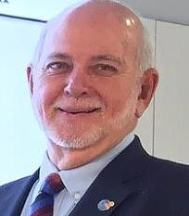

In an effort to increase membership and highlight Rotary’s inspiring work, RI President

Barry Rassin is urging clubs and districts to organize fun, informal community events called

Rotary Days.

"Rotary Days events will offer you the chance to have an impact in your community, build

long-term partnerships, increase interest in membership, and improve Rotary’s image."

Rassin said. Any club, big or small, can host a Rotary Day. Neighboring clubs can pool their resources and co-host an event, and entire districts can come together for a large-scale Rotary Day.

Please send information on club activities, progress reviews on service projects, relevant photos etc to:

BC Editor: RR Shrestha email: rryesrr@gmail.com

## 4 Jan 2019 The Weekly Bulletin of Rotary Club of Kathmandu Mid-Town bc-15.1/019